UIAO Core Ingestion and Evidence Pipeline
Complete Deliverables Package
SCuBA Adapter + KSI Evidence Linker + Governance/CI Integration
April 2026
“Transforming vendor-specific security reports into standardized, audit-ready OSCAL evidence.”

Table of Contents
1. Automated UIAO Compliance Pipeline Diagram
2. Understanding the UIAO Core Ingestion and Evidence Pipeline
2.1 What Problem Does This Component Solve?
2.2 What This Component Is (In Plain English)
2.3 How the Data Flows Through the System
2.4 Why This Matters (The Real-World Impact)
2.5 Summary
3. Microsoft Learn Module Outline
4. Comic-Style Explanation: The Adventures of SCuBA and the Evidence Machine
5. Leadership-Facing One-Page Summary
6. Technical Deep Dive for Engineers

1. Automated UIAO Compliance Pipeline: SCuBA to OSCAL
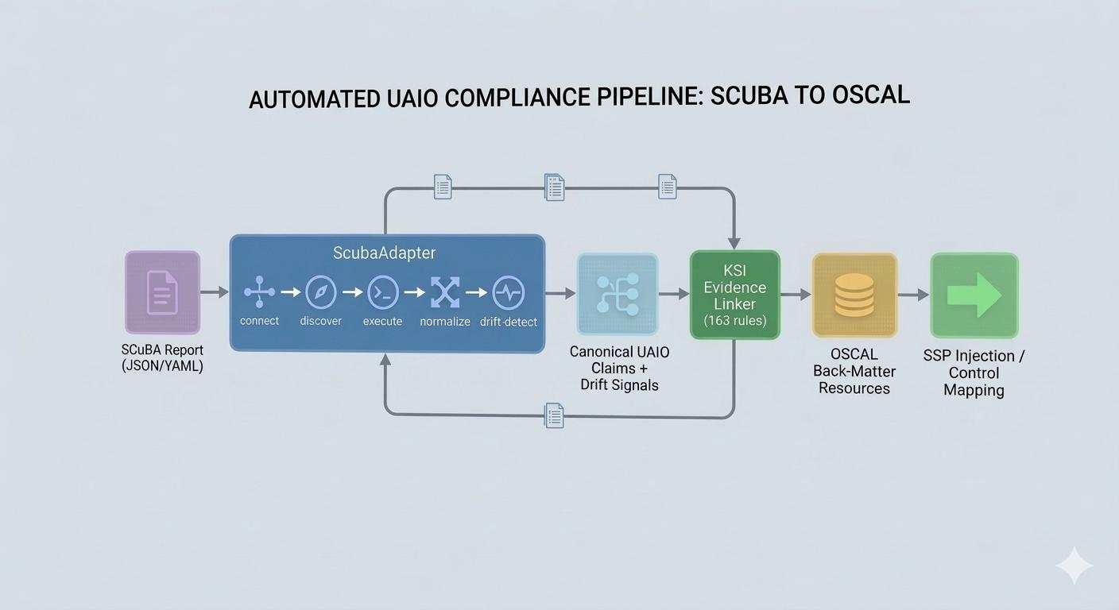
Figure 1 — Automated UIAO Compliance Pipeline: SCuBA to OSCAL
Figure 2 — Detailed Pipeline Architecture (Text Diagram)
┌────────────────────────────────┐
│ SCuBA Report File │
│ (JSON or YAML from M365) │
└──────────────┬─────────────────┘
│
▼
┌────────────────────────────────┐
│ UIAO SCuBA Adapter │
│ - connect() │
│ - discover_schema() │
│ - execute_query() │
│ - normalize() │
│ - detect_drift() │
│ - collect_and_align() │
└──────────────┬─────────────────┘
│
▼
┌────────────────────────────────┐
│ Canonical UIAO Claims │
│ (vendor-neutral truth fabric) │
└──────────────┬─────────────────┘
│
▼
┌────────────────────────────────┐
│ KSI Evidence Linker │
│ - loads 163 KSI rules │
│ - maps to NIST 800-53 │
│ - builds EvidenceArtifacts │
│ - generates OSCAL resources │
└──────────────┬─────────────────┘
│
▼
┌────────────────────────────────┐
│ OSCAL Back-Matter Output │
│ - evidence resources │
│ - control mappings │
│ - SSP injection blocks │
└──────────────┬─────────────────┘
│
▼
┌────────────────────────────────┐
│ ATO / FedRAMP Documentation │
│ - machine-verifiable evidence │
│ - drift summaries │
│ - audit-ready artifacts │
└────────────────────────────────┘

2. Understanding the UIAO Core Ingestion and Evidence Pipeline
How UIAO turns messy vendor data into clean, trustworthy, audit-ready evidence

Introduction
Modern cloud environments generate enormous amounts of configuration data, logs, and security reports. Every vendor formats this information differently, uses different terminology, and organizes their settings in unique ways.
For agencies and enterprises, this creates a major challenge:

“
How do you turn all these inconsistent reports into a single, trustworthy, repeatable source of truth?
”

UIAO (Unified Identity, Addressing, and Observability) solves this by acting as a translator, cleaner, and evidence generator.
The component completed — the SCuBA Adapter + KSI Evidence Linker — is the first fully operational example of this pipeline.
This module explains:
- What this component does
- Why it exists
- How data flows through it
- How it supports audits, ATOs, and continuous monitoring

2.1 What Problem Does This Component Solve?
Agencies rely on tools like SCuBA (Secure Cloud Business Applications) to check whether Microsoft 365 environments follow federal security baselines.
But SCuBA reports are:
- Vendor-specific
- Hard to compare across systems
- Not aligned to NIST controls
- Not directly usable in OSCAL or ATO packages
UIAO fixes this by:
- Reading SCuBA reports
- Translating them into UIAO's universal format
- Detecting drift from expected baselines
- Mapping results to NIST 800-53 controls
- Generating OSCAL evidence automatically
This turns a raw vendor report into clean, consistent, audit-ready evidence.

2.2 What This Component Is (In Plain English)
This UIAO Core component is made of two major parts:

A. The SCuBA Adapter
A specialized "reader" that understands SCuBA reports and converts them into UIAO's universal language.
It performs tasks like:
- Opening the SCuBA report
- Understanding its structure
- Extracting settings and results
- Normalizing them into UIAO's standard format
- Detecting when something is out of compliance
- Preparing the data for evidence generation
Think of it as a universal translator for Microsoft 365 security baselines.

B. The KSI Evidence Linker
Once the adapter produces clean, normalized data, the Evidence Linker:
- Reads UIAO's 163 KSI rules (Knowledge, Signals, and Inference rules)
- Matches SCuBA findings to NIST 800-53 controls
- Creates OSCAL back-matter evidence files
- Builds control-to-evidence maps
- Injects evidence into an SSP (System Security Plan)
Think of it as a machine that turns raw findings into official audit evidence.

2.3 How the Data Flows Through the System

Step 1 — A SCuBA Report Is Generated
An agency runs Microsoft's SCuBA tool, which produces a report in JSON or YAML. This report contains security settings, compliance results, policy IDs, and product-specific findings (AAD, EXO, SharePoint, Teams, Defender). At this stage, the data is vendor-specific and not standardized.

Step 2 — UIAO's SCuBA Adapter Reads the Report
The adapter opens the file, identifies the format (JSON/YAML), loads the data into memory, and validates that it matches expected SCuBA schemas. This is similar to opening a spreadsheet and checking that the columns make sense.

Step 3 — The Adapter Normalizes the Data
This is the most important part. The adapter converts SCuBA's vendor-specific fields into UIAO's canonical claim format, such as:
- uiao.policy.id
- uiao.policy.expected_value
- uiao.policy.actual_value
- uiao.policy.status
- uiao.policy.product
- uiao.policy.nist_controls
This step ensures that every vendor, every product, and every report uses the same structure. This is what makes UIAO a "unified truth fabric."

Step 4 — Drift Detection Runs
UIAO compares what SCuBA says vs. what the baseline expects. If something is misconfigured, missing, or out of alignment, UIAO generates a drift signal.
Example: "Teams external sharing is enabled, but baseline requires it to be disabled."
These drift signals become part of the evidence package.

Step 5 — The Adapter Emits Canonical Claims
After normalization and drift detection, the adapter produces a clean, structured set of UIAO claims. These claims are:
- Vendor-neutral
- Machine-readable
- Consistent across all adapters
- Ready for evidence generation
This is the "truth" that UIAO uses internally.

Step 6 — The KSI Evidence Linker Processes the Claims
The Evidence Linker loads all 163 KSI rules, matches each SCuBA claim to relevant rules, determines which NIST controls apply, creates EvidenceArtifacts, builds OSCAL back-matter entries, and prepares SSP injection blocks. Raw SCuBA findings become official OSCAL evidence.

Step 7 — OSCAL Evidence Is Generated
The output includes:
- Back-matter resources
- Control-to-evidence mappings
- Evidence summaries
- SSP-ready text blocks
- Machine-verifiable artifacts
This is the exact format required for FedRAMP, ATO packages, continuous monitoring, audits, and inheritance models.

Step 8 — CI Validates Everything
The lint fixes and tests ensure:
- The adapter works
- The evidence linker works
- The CLI command works
- The repository stays drift-free
- Every change is validated automatically
This enforces UIAO's governance model: No drift. No ambiguity. No broken pipelines.

2.4 Why This Matters (The Real-World Impact)
This component enables agencies to:
- Automatically convert SCuBA output into NIST-aligned evidence
- Detect configuration drift in Microsoft 365
- Produce OSCAL artifacts without manual work
- Maintain a consistent, repeatable compliance pipeline
- Reduce audit preparation time from weeks to minutes
- Support multi-cloud, multi-vendor environments with a single framework
It is the first fully operational example of UIAO's vision: A unified, deterministic, machine-verifiable truth fabric for identity, addressing, and observability.

2.5 Summary
- The SCuBA Adapter reads Microsoft 365 SCuBA reports and converts them into UIAO's universal claim format.
- The KSI Evidence Linker takes those claims and generates OSCAL evidence aligned to NIST 800-53.
- The CI governance layer ensures the entire pipeline remains deterministic, validated, and drift-free.
- Together, they form a complete ingestion, normalization, drift detection, and evidence generation pipeline.
- This pipeline transforms vendor-specific reports into standardized, audit-ready evidence suitable for ATOs and continuous monitoring.

3. Microsoft Learn Module Outline
Module Title: Transforming SCuBA Reports into OSCAL Evidence with UIAO

Learning Objectives
By the end of this module, you will be able to:
- Describe how UIAO ingests and normalizes vendor-specific security reports
- Explain how the SCuBA Adapter converts Microsoft 365 baselines into canonical UIAO claims
- Understand how the KSI Evidence Linker maps claims to NIST 800-53 controls
- Trace the full data flow from SCuBA to UIAO to OSCAL
- Identify how UIAO supports ATO, FedRAMP, and continuous monitoring workflows

Unit 1 — Introduction to UIAO's Evidence Pipeline
- Why cloud security data is inconsistent across vendors
- The role of UIAO as a "truth fabric"
- Overview of adapters, claims, and evidence generation

Unit 2 — Understanding SCuBA and Its Output
- What SCuBA is and why agencies use it
- Structure of SCuBA JSON/YAML reports
- Challenges with using SCuBA directly for audits

Unit 3 — The SCuBA Adapter Lifecycle
- How UIAO adapters follow a consistent lifecycle
- Breakdown of each method: connect(), discover_schema(), execute_query(), normalize(), detect_drift(), collect_and_align()
- How normalization creates vendor-neutral claims

Unit 4 — Drift Detection and Canonical Claims
- What drift is and why it matters
- How UIAO identifies misconfigurations
- How claims become the foundation for evidence

Unit 5 — The KSI Evidence Linker
- Purpose of KSI rules
- How 163 YAML rules map to NIST controls
- How EvidenceArtifacts are created
- How OSCAL back-matter is generated

Unit 6 — Producing Audit-Ready OSCAL Evidence
- How UIAO outputs OSCAL resources
- How evidence is injected into SSPs
- How this supports ATO and continuous monitoring

Knowledge Check
Multiple-choice questions about the pipeline covering adapter lifecycle, drift detection, KSI rule matching, and OSCAL output generation.

Summary
Review of the full SCuBA → UIAO → OSCAL flow. Key benefits for agencies and auditors.

4. Comic-Style Explanation: The Adventures of SCuBA and the Evidence Machine
A lighthearted walkthrough of the UIAO pipeline — panel by panel.

Panel 1 — The Messy Report
SCuBA stands holding a giant, messy stack of JSON and YAML papers.
“I checked your Microsoft 365 settings... but I speak my own language!”

Panel 2 — Enter UIAO Adapter
A friendly robot labeled UIAO Adapter rolls in with a translator headset.
“Don't worry, SCuBA. I can read your reports and turn them into something everyone understands.”

Panel 3 — Normalization Chamber
The adapter feeds the messy papers into a glowing machine. Out the other side come clean, uniform cards labeled Canonical Claims.
“Perfect! Now everything is consistent and vendor-neutral.”

Panel 4 — Drift Detector
A radar screen lights up with red blips.
“Uh-oh! Some settings don't match the baseline. I'll flag those as drift.”

Panel 5 — KSI Evidence Linker Appears
A librarian-wizard character opens a giant spellbook labeled 163 KSI Rules.
“Let me match these claims to the correct NIST controls.”

Panel 6 — OSCAL Evidence Factory
The wizard and robot feed claims into a machine that stamps out official-looking OSCAL documents.
“Behold! Audit-ready evidence!”

Panel 7 — The Auditor Arrives
An auditor smiles, holding the OSCAL package.
“This is perfect. Everything is traceable, consistent, and machine-verifiable.”

Panel 8 — Final Shot
SCuBA, the Adapter, and the Evidence Linker pose heroically.
“Together, they turn chaos into compliance.”

5. Leadership-Facing One-Page Summary

UIAO SCuBA Integration — Executive Summary
UIAO now provides a complete, automated pipeline that transforms Microsoft's SCuBA security reports into standardized, audit-ready OSCAL evidence. This capability eliminates manual interpretation, reduces audit preparation time, and ensures consistent, machine-verifiable compliance across Microsoft 365 environments.

What This Enables
• Automated ingestion of SCuBA reports (JSON/YAML)
• Normalization into a universal format used across all UIAO adapters
• Drift detection against federal baselines
• Automated mapping to NIST 800-53 controls
• Generation of OSCAL back-matter evidence suitable for ATO and FedRAMP packages

Why It Matters
Agencies struggle with inconsistent vendor formats and manual evidence creation. UIAO solves this by providing:
• A single, deterministic truth fabric
• Repeatable, automated evidence generation
• Reduced audit burden
• Improved accuracy and traceability
• Support for continuous monitoring

Strategic Impact
This integration demonstrates UIAO's ability to unify multi-vendor security data into a consistent, governance-aligned model. It establishes the foundation for additional adapters (AWS, GCP, Azure Policy, Defender for Cloud) and positions UIAO as a cross-cloud compliance automation platform.

6. Technical Deep Dive for Engineers

Overview
The SCuBA Adapter + KSI Evidence Linker form a complete ingestion-to-evidence pipeline inside UIAO Core. This section explains the internal mechanics, data structures, and lifecycle patterns.

Adapter Architecture
All UIAO adapters follow a strict lifecycle contract:

Method | Description
connect() | Validates input, loads SCuBA JSON/YAML, ensures schema compatibility
discover_schema() | Identifies product types (AAD, EXO, SPO, Teams, Defender), extracts policy IDs and metadata
execute_query() | Reads SCuBA findings, normalizes vendor-specific fields
normalize() | Converts SCuBA fields into canonical UIAO claim objects, ensures consistent naming, typing, and structure
detect_drift() | Compares actual vs. expected values, emits drift signals with severity and rationale
collect_and_align() | Aligns claims with the vendor overlay (scuba.yaml), ensures product-to-control mapping consistency
get_ksi_evidence() | Prepares claims for the Evidence Linker

Canonical Claim Format
Each normalized claim includes the following fields:

Field | Purpose
policy_id | Unique identifier for the policy being evaluated
product | M365 product (AAD, EXO, SPO, Teams, Defender)
expected_value | Baseline-expected configuration value
actual_value | Value observed in the SCuBA report
status | Pass, fail, or warning
nist_controls | Mapped NIST 800-53 control identifiers
evidence_source | Provenance of the data (adapter + report reference)
drift_detected | Boolean flag indicating configuration drift

This format is shared across all UIAO adapters.

KSI Evidence Linker Internals
The linker operates through the following sequence:
- Loads all 163 KSI YAML rules
- Converts each into a KsiRule object
- Matches claims to rules based on: policy ID, product, control family
- Produces EvidenceArtifact objects
- Delegates to EvidenceLinker to generate:
  - OSCAL back-matter.resources
  - Control-implementation mappings
  - SSP injection blocks
Artifacts include: UUIDs, media type, provenance, claim references, and timestamps.

OSCAL Output
The final OSCAL output includes:
- Evidence resources
- Control mappings
- Component definitions
- SSP-ready text blocks
- Drift summaries
All outputs are deterministic and reproducible.

Testing and CI Integration

Metric | Detail
Total Tests | 17 tests across 6 classes
Coverage Areas | Schema validation, drift detection, evidence generation, CLI integration

CI ensures:
- No lint errors
- No unused variables
- No type errors
- No drift in expected outputs

Governance Guarantee
Every commit is validated against the full test suite. The pipeline enforces a zero-drift, zero-ambiguity standard — ensuring that OSCAL evidence output remains deterministic across all runs.

UIAO Core Ingestion and Evidence Pipeline — Complete Deliverables Package | April 2026 | Confidential

